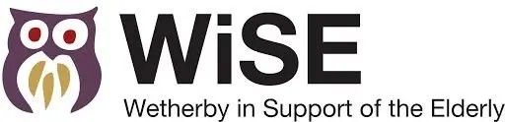
The WiSE Bramham Social
Calling all Bramham residents.. we have a new social event coming near you!
Our new Bramham Social is an afternoon activity similar to Elderberries. This month, professional singer Clayton Brooks will be performing timeless swing classics to keep you all entertained.

📆When - Thursday 23rd September
🕰Time - 2pm-4pm
🕍Where - Bramham Village Hall
💷Price - £3 including refreshments.

You don’t have to live in Bramham to attend. For transport to get you there, phone Jo on 01937 541441.

